Program Structures and Algorithms

Spring 2023(SEC – 03)

NAME: Changyu Wu

NUID: 002111594

**Task: Assignment 5 (Parallel Sorting)**

**Relationship Conclusion:**

1. Algorithm with 2 threads works worst. Threads between 4 to 16 have similar efficacy.
2. Except the 2 threads test, before cutoff/arraySize equals 0.5, the performance of parallel sort is good. After 0.5, the algorithm efficacy becomes significantly worse.

**Evidence to support that conclusion:**

I changed part of the code in Main.java and ParSort.java. Because I think in the Main.java file, the way to calculate time is slightly defective. And in the ParSort.java, I add a new object ForkJoinPool to test algorithm under different threads.

Testing results are stored in the spreadsheet called “cutoff_size_performance.xlsx”. I tested threads from 2 to 16, and cutoff/arraySize ratio are ranged from 0.05 to 1.

**Graphical Representation:**

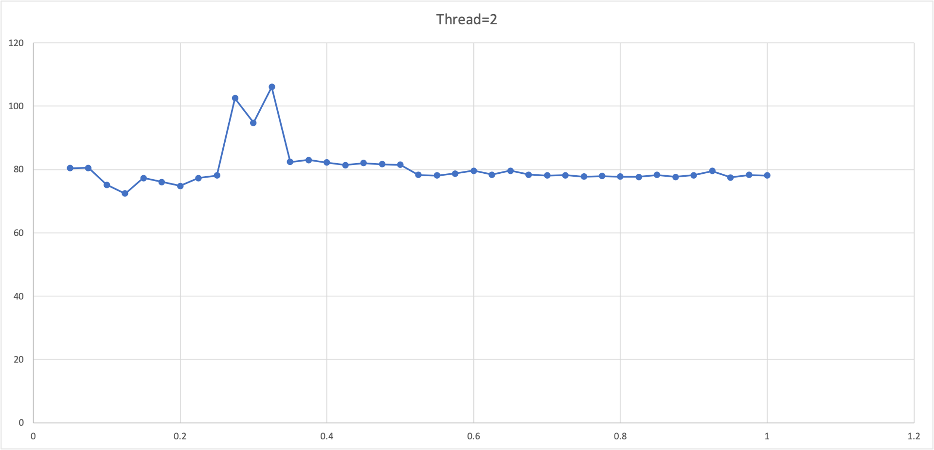

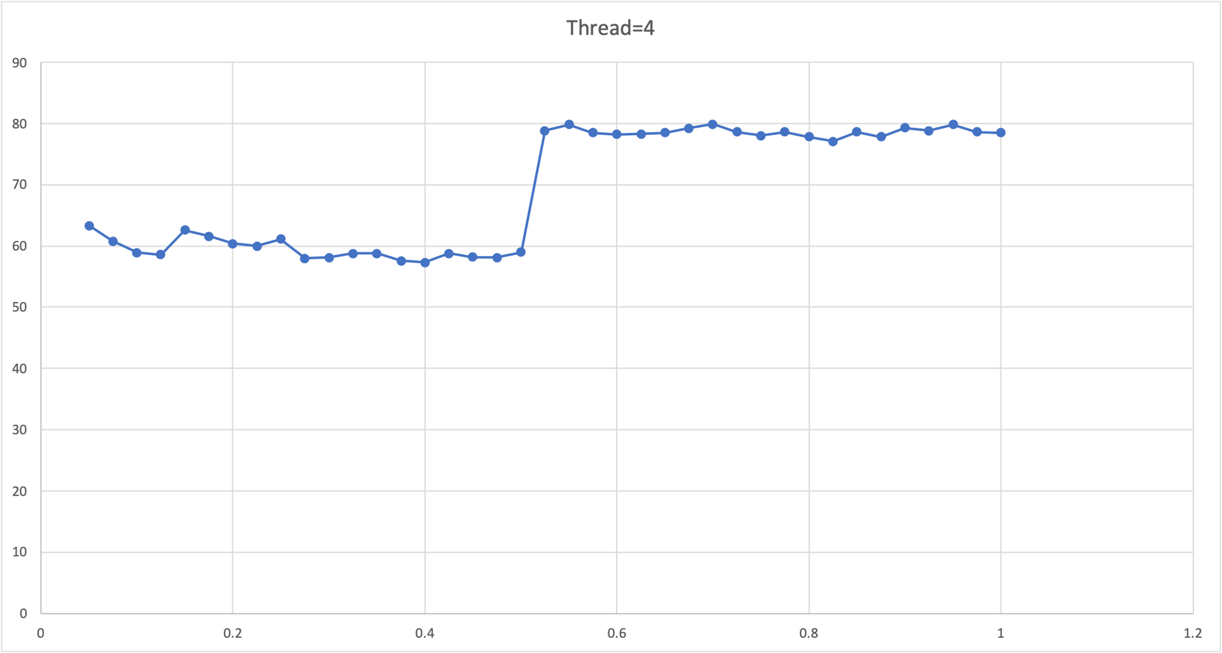

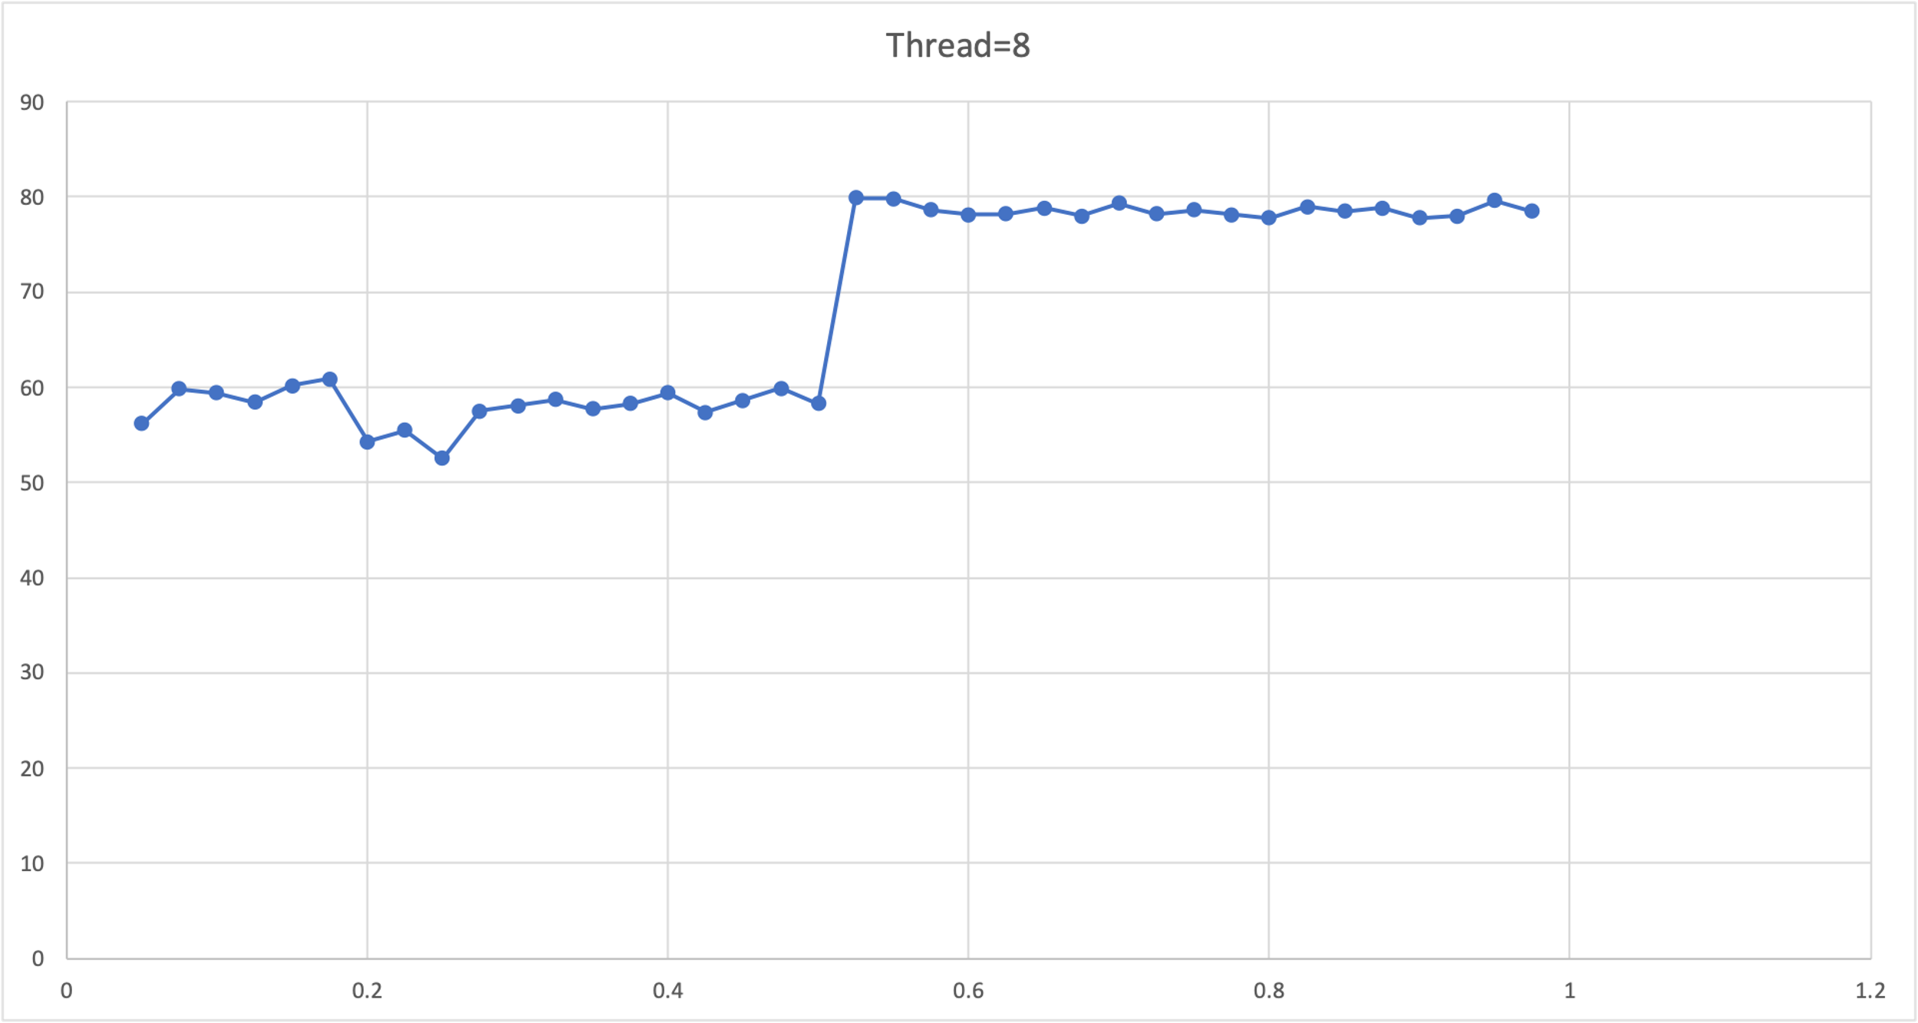

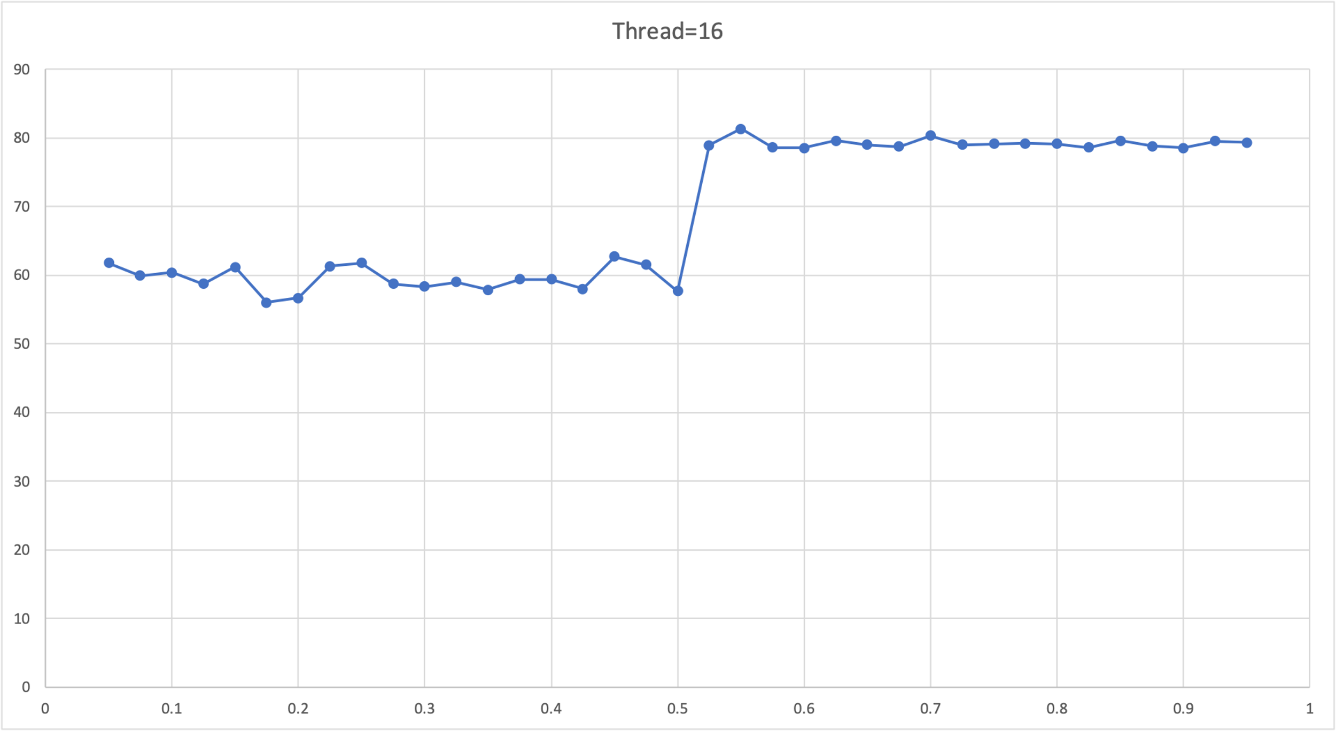

**Unit Test Screenshots:**

